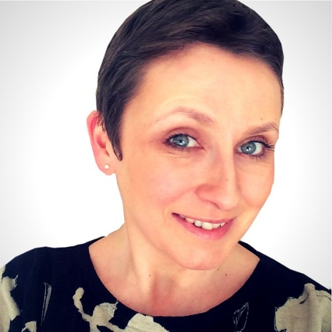
Welcome Packet

Hey there,
Congratulations and welcome to Coaching Sensation!
In order to start you on the way to greater clarity, please work complete the following welcome packet.
Thank You
Jo & Team
Your Desires

What are your reasons for investing in this coaching programme?

What is your “Why?” Be really specific.

What are your specific goals for this coaching programme and for taking your life and business to the next level?

What specifically do you want to accomplish by the end of this coaching programme?

How committed are you to achieving and completing your stated goals? What, specifically, are you prepared to change and do to achieve them?

What, specifically, do you believe will be the most difficult part, or the biggest obstacle to success for you?

What, specifically, can you do to overcome these obstacles?

What return on investment are you committed to creating for yourself, in relation to this coaching programme, and by when? (i.e. what proﬁt amount do you need to make in order for this to be a “good investment” for you?)

Your Mindset

What, specifically, are you currently doing to cultivate a mindset of success and abundance?

What, specifically, are you currently doing to nourish your emotional wellbeing?

How would you rate your current levels of excitement, enthusiasm and motivation around your current business/idea on a scale of 1-10?

How would you describe your current levels of excitement, enthusiasm and motivation around your current business/idea?

How would you rate your current levels of energy, vitality and physical motivation on a scale of 1-10?

How would you describe your current levels of energy, vitality and physical motivation?

Your Circumstances

What, specifically, has kept you from accomplishing these goals in the past?

Describe your relationship with money.

How many hours are you currently working per week?

What other personal and business development work have you done? Please list all programmes, seminars, coaches, mentors, books etc. that have been part of your development:

Which of these programs have been the most helpful for you and why?

Which of these programs have been the least helpful for you and why?

What are YOUR specific strengths and weaknesses?

If you could wave a magic wand and change three things in your life or business, what would they be?

Getting Down To Business

Describe your business and it’s specific purpose

If in business, how long have you been in business?

Describe the current status of your business in terms of marketing effectiveness, client capacity and profitability?

If in business, what is your specific vision for your business?

What are the specific strengths and weaknesses of YOUR BUSINESS (or, business idea)?

Are you ready to hire a Virtual Assistant or other help?

What is your computer proficiency?

Marketing

Who is your target market? Who are the specific people you ideally want to work with and serve?

What is your target market’s biggest frustration?

What products or services can you offer to heal your target market’s wound or solve their problem? Be Speciﬁc.

Which marketing channels are you currently using, and/or what have you used in the past?

Which have been the most successful for you?

What is your monthly advertising budget?

Are you interested in developing a speaking presence (becoming a speaker to promote your business)?

Business Structures

Do you have a website? If yes, what’s the URL?

Do you have a blog? If yes, what’s the URL?

Do you have a squeeze/lead/opt-in/sales page? If yes, what’s the URL?

Do you have a mailing list/email list? If yes, how many subscribers do you have?

Do you have a brand image (logo, graphics, etc.)?

Social Media
Facebook Page and Number of followers, if appropriate.

Facebook (or LinkedIn) Group you manage, and Number of Members, if appropriate

Twitter Handle and Number of Followers, if appropriate

LinkedIn Profile and Number of followers

Finances

What is your current monthly income?

What is your monthly income goal?

Why, specifically, have you chosen this monthly income goal?

How will this money change your life?

Who else’s life will it change, and how (specifically)?

What is your current financial status? (e.g. have capital/savings to invest? Making ends meet? In debt?)

Final Thoughts

What do you most want from Jo in this coaching programme?

Create a commitment statement, and promise yourself how you will turn up throughout this programme, to make sure you get the best possible results…

